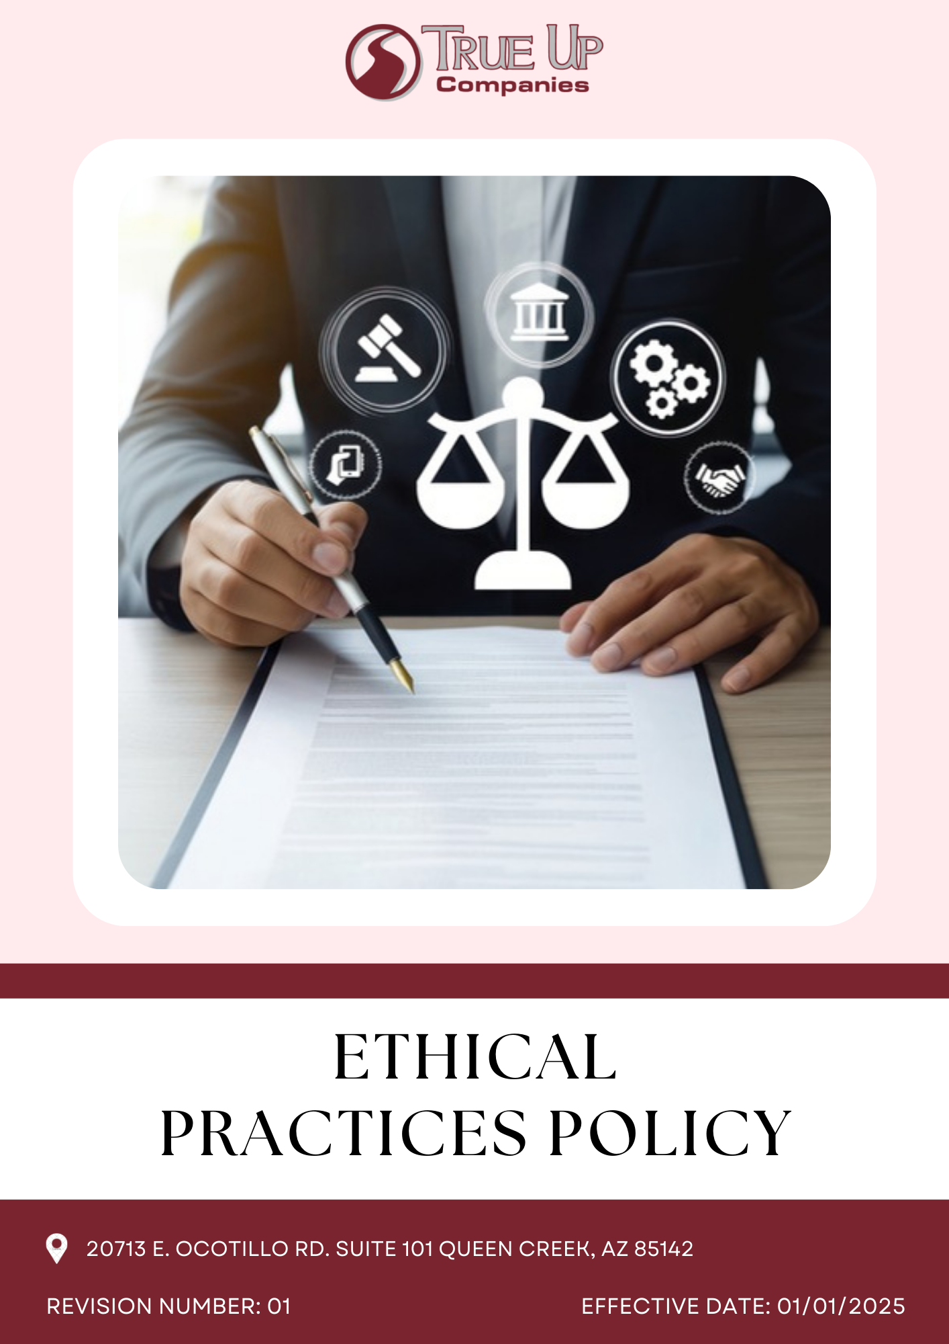

Table of Contents
Introduction 3
Scope 3
Policy Statement 3
Key Focus Areas 3
Sustainable Objective (Baseline- 2022) 4
Targets 5
Example & Guidance 7
Handling Violations of Policy 8
Governance and Allocation of Responsibilities 8
Reporting and Communication Framework 9
SDGs Covered 10
Review Mechanism 11
Employee Acknowledgement 12

Introduction
At TRUE UP COMPANIES LLC, we prioritize integrity, transparency, and ethical responsibility in all aspects of our operations. Our Ethical Practices Policy serves as a foundation for decision-making, ensuring that our business practices align with legal requirements, industry regulations, and our core values. We are dedicated to maintaining accountability at all levels, fostering stakeholder trust, and upholding ethical excellence. This policy establishes clear guidelines for preventing corruption, addressing conflicts of interest, mitigating fraud risks, ensuring compliance with financial regulations, strengthening stakeholder relationships, evaluating leadership performance, and safeguarding sensitive information.

Scope
At TRUE UP COMPANIES, our Ethical Practices Policy extends across all aspects of our e-commerce, supply chain, and customer service operations. This policy applies to employees, contractors, vendors, and all stakeholders within our business ecosystem, ensuring that ethical governance is upheld at every level of our organization. We are committed to integrity, transparency, and fairness in our interactions with customers, partners, and the broader community.
TRUE UP COMPANIES LLC
20713 E. Ocotillo Rd. Suite 101 Queen Creek, AZ 85142
Policy Statement
At TRUE UP COMPANIES LLC is committed to maintaining the highest standards of ethical conduct in all aspects of our operations. We pledge to uphold integrity, honesty, and fairness in our dealings with employees, customers, suppliers, and the communities we serve. Our Ethical Practices policy emphasizes transparency, accountability, and respect for all individuals, ensuring a work environment free from discrimination, harassment, and unethical practices. We are dedicated to fostering a culture where ethical decision-making guides our actions, and we will continuously evaluate and reinforce our commitment to these principles across all levels of the organization.

Key Focus Areas
- Preventing Corruption: We enforce strict anti-corruption policies, ensuring a zero-tolerance approach to unethical behaviour. Strong internal controls help us detect and address any misconduct.
- Fair Business Practices: We commit to honest advertising, transparent pricing, and ethical competition to maintain customer trust.
- Managing Conflicts of Interest: Clear guidelines are in place to identify, disclose, and mitigate any conflicts of interest, ensuring transparency in decision-making.
- Anti-Fraud & Cybersecurity: We safeguard transactions, prevent fraud, and protect customer information through advanced security measures.
- Anti-Money Laundering (AML) : Enforce compliance with AML laws and conduct due diligence on financial transactions.
- Information Security: Protect sensitive data through secure technologies and compliance with data privacy laws.
- Enhancing Stakeholder Engagement: Open communication with stakeholders is a priority, fostering trust and collaborative partnerships for mutual growth.
- Corporate Social Responsibility (CSR): TRUE UP COMPANIES actively contributes to community development initiatives, supporting education, skill development, and local employment opportunities.
- Sustainability & Environmental Responsibility: We implement eco-friendly packaging, responsible shipping, and sustainable business operations.

Objectives
- Anti-Corruption Measures
- We maintain a zero-tolerance policy for bribery, kickbacks, and unethical influence.
- Integrate anti-corruption clauses in all contracts with suppliers and business partners to ensure compliance.
- Employees and partners are expected to report any suspicious activities through a Whistle blower mechanism.

- Conflict of Interest Management
- We require full disclosure of any personal or financial interests that may impact business decisions
- Require annual conflict of interest disclosures from senior management and key decision-makers.
- Employees must act in the best interests of the company and its stakeholders.

- Fraud Prevention and Risk Mitigation
- Strengthen internal controls to reduce fraud risks within production, supply chain, and financial operations.
- Maintain an anonymous reporting channel for employees to report fraud concerns safely.
- Regular risk assessments help protect customers, partners, and the company.

- Anti-Money Laundering Compliance
- Enforce a robust Know-Your-Customer (KYC) process for all financial transactions and partnerships.
- We comply with all laws to prevent money laundering, terrorist financing, and financial crimes.
- Transactions are monitored for suspicious activities and reported when necessary.
- Conduct due diligence for all vendors, suppliers, and business partners.

- Information Security and Data Protection
- We prioritize customer data protection through secure systems and compliance with global privacy laws.
- Train employees on secure data handling practices to prevent breaches.

- Stakeholder Engagement and Transparency
- Conduct biannual stakeholder meetings to discuss governance, ethical practices, and business sustainability.
- Publish detailed reports on governance initiatives and progress in alignment with industry standards.
- Actively seek feedback from employees, customers, and business partners to refine governance practices.
- Board Evaluation and Accountability
- Conduct annual evaluations of board performance against defined governance benchmarks.
- Implement a feedback mechanism to enhance board decision-making processes.
- Develop training programs for board members to strengthen governance knowledge.
- Review the alignment of board decisions with company objectives and governance standards.
- Ensure documentation and transparency in board activities and resolutions.

Targets
Year 2022 has been considered as the baseline year for measuring and tracking progress toward all our targets.
- Anti-Corruption
- Maintain 85% compliance with anti-corruption policies across all supplier and partner contracts by year 2028.
- Conduct annual anti-corruption training for 100% of employees and business partners.
- Maintain zero incidents of bribery, kickbacks, or unethical influence in business dealings.

- Conflict of Interest Management
- Ensure that 100% of procurement decisions are reviewed annually, with a target of reducing procurement-related conflicts by 20% by year 2028.
- Increase employee participation in conflict management training to 60% by 2028.
- Implement real-time monitoring of key business transactions with 95% accuracy in detecting conflicts

- Fraud Prevention and Risk Mitigation
- Maintain zero fraud-related incidents through enhanced monitoring, stricter controls, and employee awareness programs.
- Implement advanced fraud detection tools, targeting a 25% improvement in financial transparency by year 2028.
- Ensure 100% of fraud reports are investigated and resolved within a predefined timeframe.

- Anti-Money Laundering Compliance
- Maintain 80% compliance with global anti-money laundering regulations (AML).
- Train 100% of finance and procurement employees in AML compliance by year 2028.
- Maintain detailed financial transaction records with 95% audit trail accuracy by year 2028.

- Anti-competitive practices
- Conduct annual training on ethical competition for at least 95% of employees.
- Perform internal audits with a 100% compliance rate to assess and improve competitive practices by year 2028.

- Information Security and Data Protection
- Ensure 100% employee participation in annual cybersecurity training.
- Conduct biannual cybersecurity audits, reducing identified vulnerabilities by 15% by year 2028.

- Stakeholder Engagement and Transparency
- Conduct annual stakeholder surveys, targeting 75% satisfaction in ethical policy transparency by 2028.
- Publish biannual governance performance reports, ensuring at least 60% stakeholder engagement by 2028.
- Establish collaborations with at least 5 industry partners by 2028 to enhance ethical business practices
- Board Evaluation and Accountability
- Conduct annual board performance evaluations for 80% of board members by 2028.
- Address 60% of board review findings within six months by 2028.
- Achieve 40% compliance with governance training for board members by 2028.
- Publish board performance summaries in 80% of governance reports by 2028.

Example & Guidance
- Preventing Corruption:
  - Example: A vendor offers a cash payment to an employee in exchange for expediting an order. The employee recognizes that this is a clear violation of the company's anti-corruption policy and promptly reports the incident to the compliance officer. The company investigates the situation, terminates the vendor’s contract, and takes corrective action to reinforce ethical standards.
  - Guidance: Employees should be trained to identify bribery and corruption and understand their responsibility to report suspicious activities. The company should also conduct periodic audits and implement a zero-tolerance policy for corruption to ensure continuous monitoring and compliance.

- Anti-Money Laundering (AML) Compliance:
- Example: If a large, unusual transaction occurs with a new supplier from a high-risk region, True Up Companies conducts thorough due diligence before proceeding with the payment.
- Guidance: True Up Companies ensures AML compliance through strict KYC procedures, transaction monitoring, and regular employee training to detect and prevent financial fraud. Strong internal controls and audits help maintain compliance and enhance collaboration with regulatory authorities.

- Managing Conflicts of Interest:
- Example: A procurement manager has a close relative who owns a vendor company. The manager discloses this relationship before procurement decisions are made.
- Guidance: All employees involved in decision-making should complete conflict-of-interest disclosures annually, and decisions should be made based on transparent criteria.
- Fair Labor Practices:
- Example: A third-party audit identifies that wages in a certain division are below industry standards. The company revises policies to ensure compliance.
- Guidance: Wage structures should be reviewed periodically to ensure fair pay and safe working conditions.
- Consumer Transparency and Ethical Marketing:
- Example: A consumer reports misleading sustainability claims on the company’s website. The company corrects the information and implements stricter marketing review processes.
- Guidance: All product claims should be verified and backed by credible data.
- Protecting Information Security:
- Example: An employee falls for a phishing email, exposing sensitive company data. The IT team quickly activates security protocols, mitigating the breach.
- Guidance: Cybersecurity training should be conducted regularly, and all employees should use multi-factor authentication.
- Board Evaluation and Accountability
- Example: To ensure effective leadership, True Up Companies conducts an annual board evaluation, assessing directors' performance, decision-making, and adherence to governance standards. For instance, feedback from stakeholders and internal audits helps identify areas for improvement in strategic oversight.
- Guidance: True Up Companies upholds board accountability through regular performance reviews, transparent decision-making, and ethical governance practices. Structured evaluation frameworks, stakeholder feedback mechanisms, and compliance audits ensure the board remains responsible, aligned with corporate goals, and committed to long-term sustainability.

Handling Violations of Policy
At true up companies, maintaining ethical integrity is paramount. Any breach of the Ethical Conduct Policy, including corruption, fraud, conflicts of interest, non-compliance with anti-money laundering regulations, or confidentiality breaches, is taken seriously. We have established a structured process to address violations and ensure accountability across all levels of the organization.
- Reporting Ethical Violations:
- We encourage all employees, suppliers, and stakeholders to report any suspected unethical behaviour through designated reporting channels. Reports can be submitted confidentially or anonymously, ensuring protection from retaliation.
- Investigation and Review Process:
- Every reported case undergoes a thorough investigation conducted by the Ethics & Compliance Team.
- Evidence gathering, witness interviews, and procedural reviews are carried out to assess the severity and impact of the violation.
- Investigations are handled objectively, fairly, and in accordance with company policies and legal requirements.
- Commitment to Continuous Improvement:
- Regular policy reviews and employee training sessions will be conducted to strengthen ethical compliance.
- Periodic audits and assessments will help identify risks and improve existing frameworks.
- Feedback mechanisms will be enhanced to encourage proactive reporting and awareness.

Responsibilities
- Leadership & Management – Set ethical standards, ensure compliance, and promote integrity.
- Employees – Adhere to ethical guidelines, report misconduct, and act responsibly.
- Ethics Committee – Oversee compliance, investigate concerns, and update policies.
- HR & Training – Implement ethics training, enforce fair practices, and address violations.
- Audit & Compliance – Monitor risks, conduct audits, and ensure legal adherence.

Reporting and Communication Framework
- Incident Reporting & Response Mechanism
- Investigation & Corrective Actions: All reported incidents are reviewed within 30 days, with corrective measures documented and implemented.
- Types of Incidents Reported: Includes cases of fraud, corruption, conflicts of interest, data security breaches, and money laundering risks.
- Reporting Channels: Employees can report concerns via HR, the Compliance Officer, or a dedicated anonymous reporting system.

- Internal Reporting Structure:
- Reporting Stakeholders: Reports are submitted to senior management, HR, the Compliance Officer, and the Board of Directors.
- Content of Reports: Includes compliance status, incidents of non-compliance, corrective measures taken, and overall governance performance.
- Reporting Timeline: Monthly compliance updates for management and a detailed annual governance report for board review.
- Employee Engagement & Ethical Culture Development:
- Information Sharing: Employees receive regular updates on governance policies, training opportunities, and ethical best practices.
- Feedback & Improvement: Employees can share suggestions through surveys, direct feedback channels, or structured discussions with HR and compliance teams.
- Recognition Programs: Employees who demonstrate exceptional commitment to compliance and ethical business conduct are acknowledged through awards and appreciation programs.

SDGs Covered
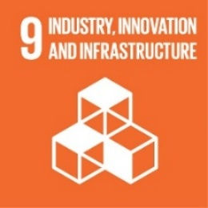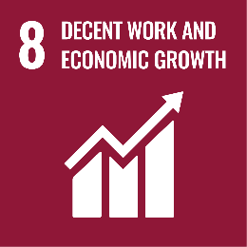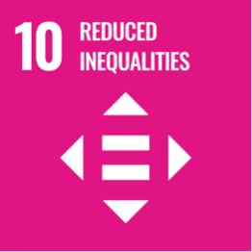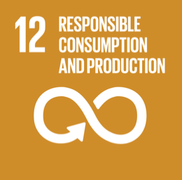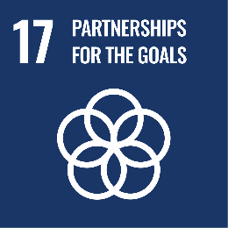

Review Mechanism
The Ethical Practices Policy will be reviewed annually by Senior Management, the Compliance Officer, and the Board of Directors. The review will assess governance performance, compliance, and incident management using data from audits, feedback, and reports. Policy updates will be proposed and approved by the Board. Changes will be communicated internally and to stakeholders through reports and meetings, ensuring alignment with company goals and industry standards.

Last Revision Date: 01.01.2025 Next Revision Date: 01.01.2026

Approved by: Signature of Approver:

Employee Acknowledgement
I hereby acknowledge that I have read and understood the Ethical Practices Policy of true up companies. I recognize the importance of adhering to the principles outlined in this policy, including maintaining integrity, preventing corruption, and ensuring compliance with legal and ethical standards. I commit to upholding these principles in my role, reporting any violations, and supporting the company’s efforts to maintain transparent and responsible governance.

Name: ____________________
Designation: _______________
Signature: _________________
Date: _____________________

